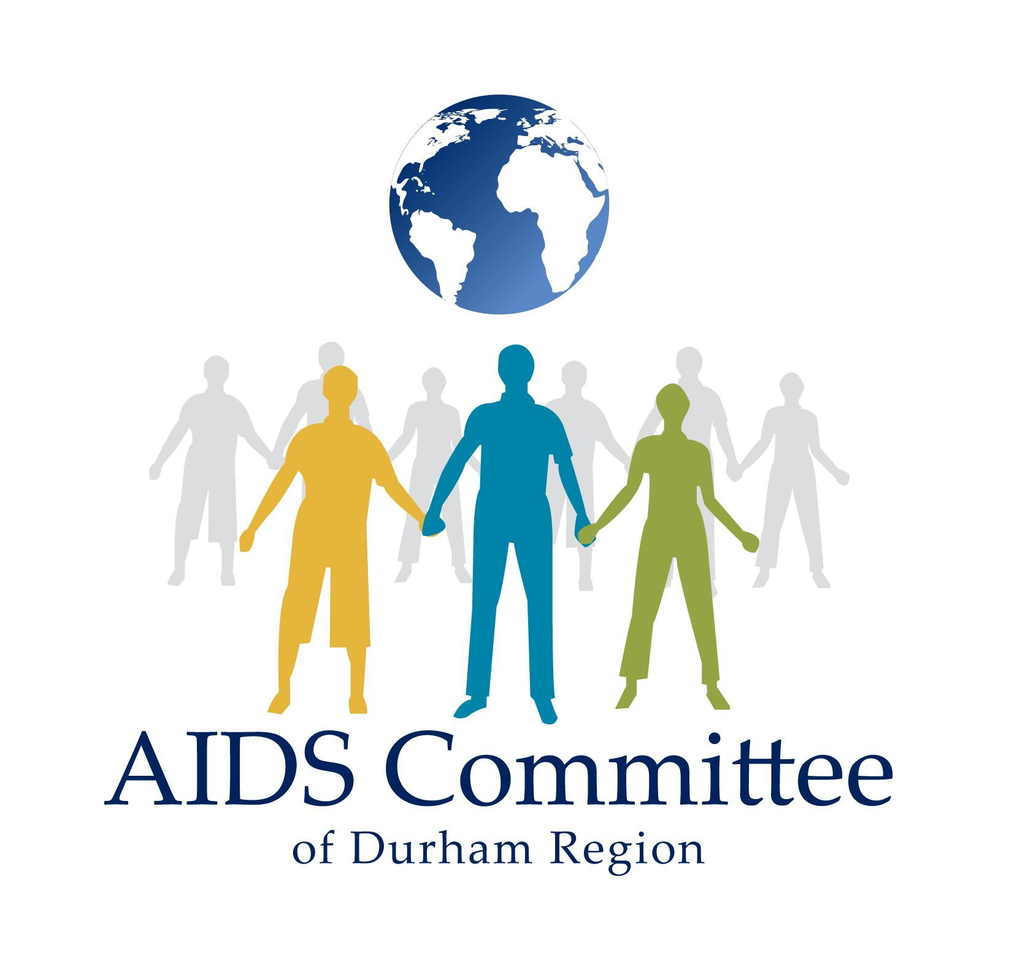
Job Description

Totally OutRIGHT Coordinator

Job Title: Totally OutRIGHT Coordinator Department: Youth/Education
Supervisor: Youth Outreach Coordinator, Manager of Education Salary: $22/hour

Job Type: 11 month contract, part-time position for 16 hours a week, evenings and weekends included, starting May 6th 2024, through March 31st , 2025.
Totally OutRIGHT is a leadership workshop series for young gay, bi, pansexual, cis and trans, and/or queer (GBTQ) guys and non-binary people interested in being healthy, smart, and sexy trailblazers in the Durham Region. It consists of HIV, STI and sexual health education through community intervention, fostering sexual health leadership in young (16 to 29) GBTQ people. Graduates are expected to demonstrate leadership by creating something to bring this information to their peers, like a pamphlet, art book, community project, or event. Totally OutRIGHT welcomes young men and non-binary people living with HIV, young GBTQ men and non-binary people, and young men and non-binary people from diverse communities to apply.

JOB DESCRIPTION
The Totally OutRIGHT Program Lead will design and coordinate this year’s series of Totally OutRIGHT workshops, recruit 5 to 10 young 2SGBTQIA+ men and non-binary people as participants. This role reports to the Youth Outreach Coordinator, and the Manager of Education and is responsible for assisting with logistics, reporting, and facilitation of Totally OutRIGHT as well as supporting the Youth Programs and other Education Programs. The Totally OutRIGHT Program Lead serves as a role model to program participants and peer workers.

Specific duties will include but are not limited to the following, and may be subject to change:

Totally OutRIGHT
- Design this year’s series of Totally OutRIGHT workshops. This includes setting curriculum and booking speakers for each learning module.
- Coordinate the planning and execution for Totally OutRIGHT, including catering, materials preparation, set up and take down.
- Facilitates and encourages participation of Totally OutRIGHT participants in workshops, project creation, and follow-through as graduates.
- Drafts communications for participants (reminders & follow-ups).

Community Development
- Create and enact a strategic recruitment plan.
- Recruit enthusiastic young queer men and non-binary people to participate in Totally OutRIGHT.
- Identifies and builds relationships with GBTQ-relevant special events and youth services, and makes these services known to Totally OutRIGHT participants.
- Develop a social media plan in collaboration with the Youth Outreach Coordinator to promote Totally OutRIGHT; manage website and online presence.
- Develop print materials to promote the program with partners.
- Support Youth and MSM Programs on an as needed basis.

Administration
- Compile a summary of each session and collates/summarises session evaluations.
- Produce an impact report about the program and project. Evaluates changes in participant knowledge from intake to graduation.
- Keep attendance and provides follow-up support to participants who are absent
- Behave in compliance with all organizational policies and procedures, and in an ethical manner that demonstrates competence in effective communication, team building, collaboration, relationship building and decision-making.
- Shares program duties in the registration of new participants, flagging special needs of participants, and helping to ensure the retention of registered participants with other staff and manager.
- Maintains registration and intake records (i.e. participant applications).

Qualifications
This is a peer-led position for a program that serves 2SGBTQIA+ men and non-binary people under 30. Applicants who identify as this population are strongly encouraged to apply. A graduate of Totally OutRIGHT is preferred but not essential.

- Strong research, writing, and evaluation skills.
- Strong ability to develop culturally relevant educational resources and programs.
- Strong ability to facilitate group programming.
- Demonstrated experience in dealing with issues regarding confidentiality, particularly young GBTQ men who may not be out to family & friends about sexual orientation or gender orientation.
- Understands and appreciates the links between sexuality, gender, health, and culture; particularly current issues affecting GBTQ men and non-binary people’s health.
- Understands and appreciates issues of diversity among various communities of GBTQ men and non-binary people.
- Excellent knowledge of spaces – in-person and digital spaces – where young GBTQ men and non-binary people gather.
- Excellent organization and planning skills.
- Strong communications skills: verbal, written, visual, and public speaking.
- Ability to work independently and as part of a team, remaining accountable, and keeping the team up-to-date.
- Ability to work flexible hours: weekly schedule may vary and will include evening and weekend work.
- Familiarity with working from a peer-based model.
- College diploma in social sciences or health promotion and/or 1 years experience facilitating programs for young, at-risk youth and/or GBTQ men and non-binary people.
- Proven computer skills (MS Excel, PowerPoint, MS Word); graphic design skill.

APPLICATION PROCESS
Please email a current resume with cover letter detailing how your qualifications and/or lived experience match this opportunity to Nathaniel Rhodes-Truppe, Youth Outreach Coordinator, AIDS Committee of Durham Region (ACDR) @ nathaniel@aidsdurham.com by 5:00pm on Friday, April 19th , 2024.

ACDR will accept applications from people who self-identify on the basis of any of the protected grounds under the Human Rights Code including but not limited to age, gender identity, race, ethnicity, in/visible disability, or sexual orientation.

Upon request, reasonable accommodation is available for applicants with disabilities throughout the recruitment process. We acknowledge that our main office location is not fully accessible; however, we strive to accommodate our staff team in coordination with community partners to ensure accessible spaces are locally available to meaningfully conduct day-to-day activities of the role.

ACDR works within a harm reduction and anti-racism, anti-oppression framework.
We encourage racialized youth, immigrant youth, youth living with disabilities, two spirited, gay, bisexual and trans youth to apply.
In accordance with GIPA & MIPA principles, qualified youth living with HIV/AIDS are strongly encouraged to apply.
We thank all candidates for their interest in the work of ACDR; however, only candidates selected for an interview will be contacted. No telephone or walk-in inquiries please.

All applications are considered confidential.

